|  |  |
| --- | --- |
| Course Name | ITD 2263 – Graphical User Interface Development |
| Instructor | Daniel D. Claborn |
| Student Name | Derrick McFall |
| Due date | Nov 17, 2017 11:59 PM |
| Grade | 100% |
| Grading Comments | Derrick,  You did a good job in completing the project.  Please keep up the good work.  Mr. Claborn |

Derrick McFall

Graphic User Interface

12-Nov-17

Chapter 20 1-7

1. 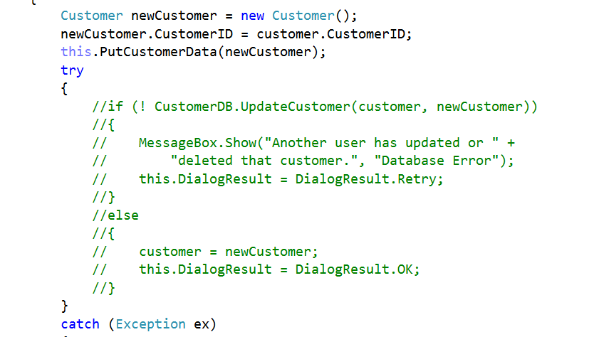
2. 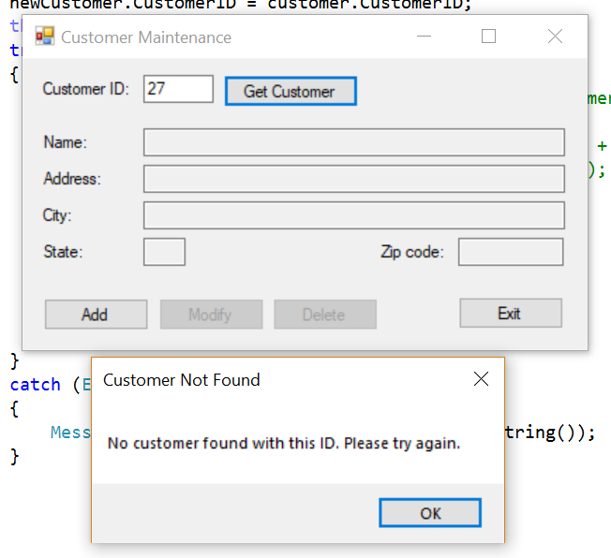
3. 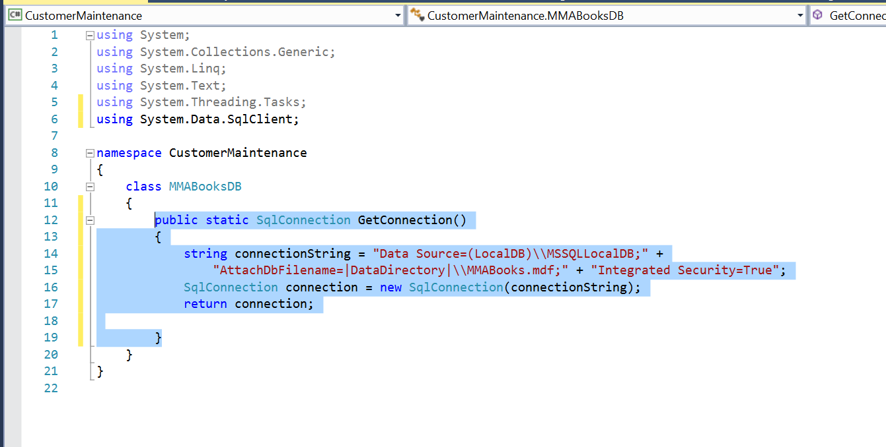

public static SqlConnection GetConnection()

{

string connectionString = "Data Source=(LocalDB)\\MSSQLLocalDB;" +

"AttachDbFilename=|DataDirectory|\\MMABooks.mdf;" + "Integrated Security=True";

SqlConnection connection = new SqlConnection(connectionString);

return connection;

} //This is the code added.

1. 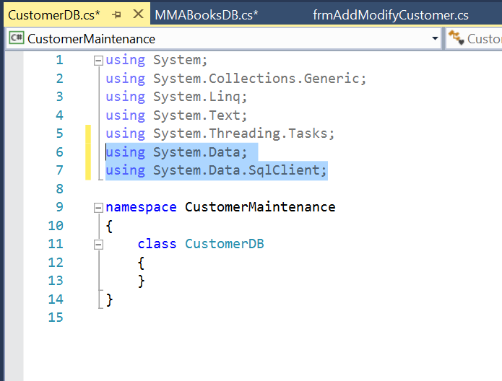

Code I input:

using System.Data;

using System.Data.SqlClient;

1. 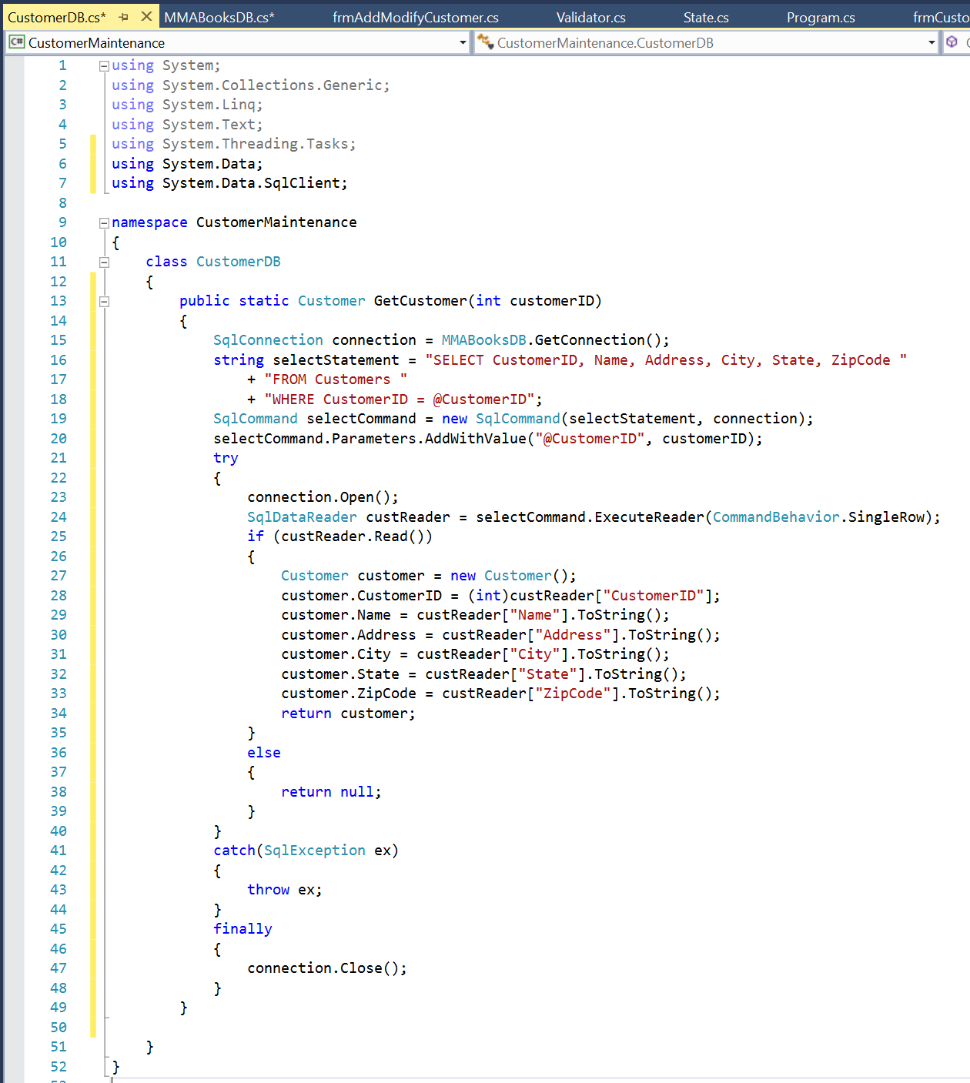

Coded added for #5

public static Customer GetCustomer(int customerID)

{

SqlConnection connection = MMABooksDB.GetConnection();

string selectStatement = "SELECT CustomerID, Name, Address, City, State, ZipCode "

+ "FROM Customers "

+ "WHERE CustomerID = @CustomerID";

SqlCommand selectCommand = new SqlCommand(selectStatement, connection);

selectCommand.Parameters.AddWithValue("@CustomerID", customerID);

try

{

connection.Open();

SqlDataReader custReader = selectCommand.ExecuteReader(CommandBehavior.SingleRow);

if (custReader.Read())

{

Customer customer = new Customer();

customer.CustomerID = (int)custReader["CustomerID"];

customer.Name = custReader["Name"].ToString();

customer.Address = custReader["Address"].ToString();

customer.City = custReader["City"].ToString();

customer.State = custReader["State"].ToString();

customer.ZipCode = custReader["ZipCode"].ToString();

return customer;

}

else

{

return null;

}

}

catch(SqlException ex)

{

throw ex;

}

finally

{

connection.Close();

}

}

1. 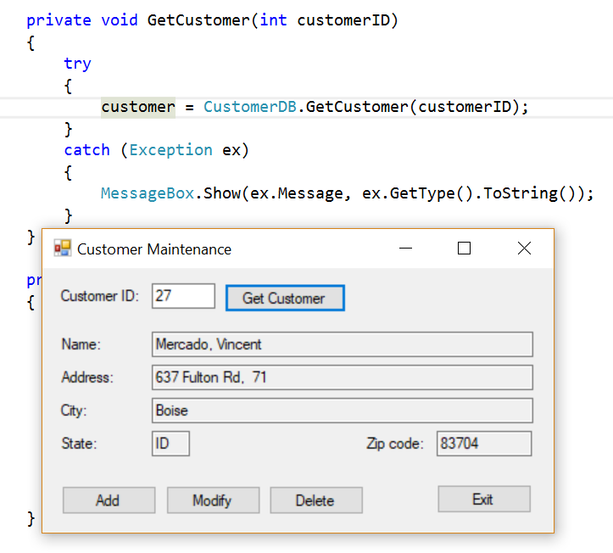
2. 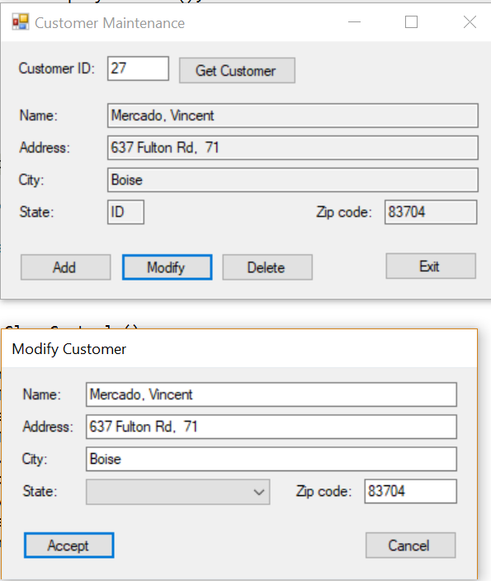

The combo box was empty but disappeared every time I clicked my snipping tool.